Declaration of Assets as they stood
on 01st Day of January, 2024
To,
The Principal Secretary to the Government of West Bengal
And
Land & Land Reforms and Refugee Relief and Rehabilitation Department,
Government of west Bengal,
6th Floor, Nabanna,
325 Sarat Chatterjee Road,
Howrah- 711102.

From,
Sri/Smt_________________________________________

Office__________________________________________

Address________________________________________

_______________________________________________

_______________________________________________

West Bengal Form No. 34A.
1st day of January, 2024.
Declaration of Assets as they stood on .

Name (In full) of Officer .... .... -Service

Designation …………… now appointed as …………………………………………….....................

Substantive Pay…………………………………………………………………………………………………………................

Special Pay
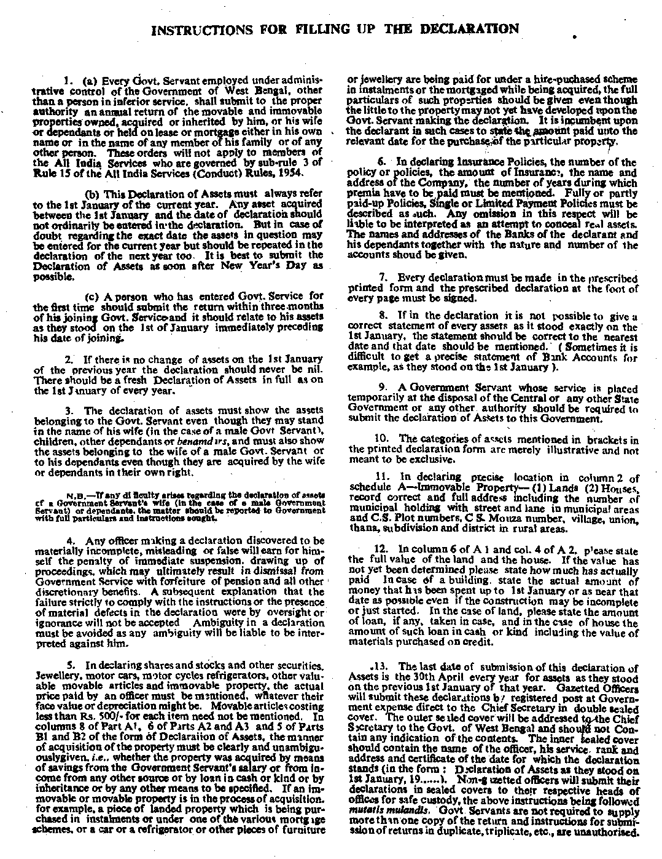

2
A—IMMOVABLE PROPERTY
(1) LANDS

Serial  No. | Precise location | Area | Nature of  land | Extent of  Interest | Value | In whose name  (wife, child,  dependant, other  relation or benamder) the  asset is | Date and manner or  acquisition | Remark
1 | 2 | 3 | 4 | 5 | 6 | 7 | 8 | 9

(2) HOUSES

Serial No | Precise location | Extent of Interest | Value | In whose name (wife, child,  dependant, other relation or benamdar) the asset is | Date and manner of acquisition | Remarks

Signature of Declarant..................................……………………….

3
(3) IMMOVABLE PROPERTIES OF OTHER DESCRIPTION
(Including mortgages and such other rights)

Serial No. | Brief Description | Extent of Interest | Value | In whose name (wife, child  dependant, other relation or  BENAMDAR) the asset is | Date and manner of acquisition | Remarks
1 | 2 | 3 | 4 | 5 | 6 | 7

B—MOVABLE PROPERTY
(1) CASH , BANK BALANCE, CREDIT, INSURANCE POLICES, SHARES, DEBENTURES, ETC.

Serial No. | Brief Description | Value | In whose name (wife, child  dependant, other relation or  BENAMDAR) the asset is | In the case of loan the name of the person from whom the loan was taken & the relationship of the loanee with that person | Date and manner of acquisition | Remarks
1 | 2 | 3 | 4 | 5 | 6 | 7
1
2.

3.
4.
5.
6.
7.
8.
9.
10.
11.
12.

Signature of Declarant ………

4
(2) OTHER MOVABLES
(Including Jewellry and other valuables, motor vehicles, refrigerators and other articles or materials of
Rs. 500 and over for each item)
Serial No. | Description of Item | Value | In whose name (wife, child, dependant, other relation or benamdaR) the asset is | Date and manner of acquisition | Remark
1 | 2 | 3 | 4 | 5 | 6

1 hereby declare that the Declaration made above is complete, true and correct to the best of my knowledge and belief.
Date Signature of Declarant- …………

